Chapter 8, Solution 24.
When the switch is in position A, the inductor acts like a short circuit so
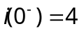
When the switch is in position B, we have a source-free parallel RCL circuit
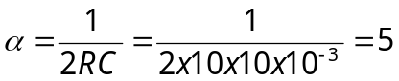
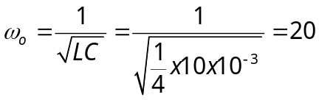
Since 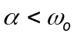, we have an underdamped case.
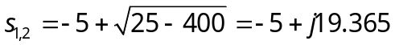
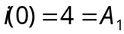
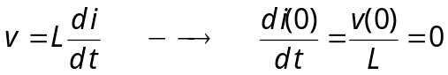
0 = [di(0)/dt] = –5A₁ + 19.365A₂ or A₂ = 20/19.365 = 1.0328

i(t) = e^{–5t}[4cos(19.365t) + 1.0328sin(19.365t)] A

